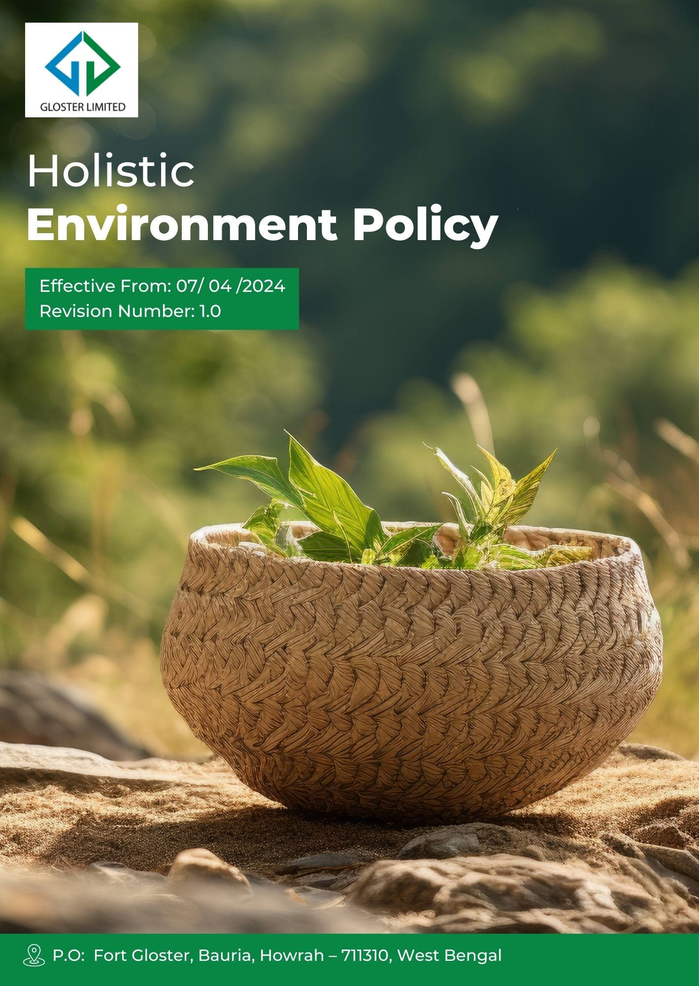
Contents
1) Preamble 3
2) Desired Outcomes 3
3) Scope 3
4) Core Environmental Strategies 4
5) Environmetal Impact Assessment (EIA) 10
6) Accountability 10
7) Progress Update 11
8) Innovation & Technology 12
9) Ongoing Development 13
10) Review Cycle 13
11) Employee Acknowledgement Form 14

Preamble
At Gloster Limited, we are deeply committed to environmental stewardship and sustainable development. Our operations recognize the significant impact manufacturing activities can have on the environment, and we are dedicated to mitigating these impacts through proactive measures and continuous improvement. We believe that sustainable practices are not only essential for the well-being of our planet but also for the longevity and success of our business. Our environmental policy outlines our commitment to reducing our carbon footprint, conserving natural resources, and promoting sustainable products. By integrating environmental considerations into every aspect of our operations, including but not limited to processing, weaving, and finishing, we aim to lead by example in the jute manufacturing industry and contribute to a more sustainable future.

Desired Outcomes
- To minimize the environmental impact of our operations through efficient resource management and waste reduction.
- To promote sustainable practices and products within the jute manufacturing industry.
- To ensure compliance with all relevant environmental regulations and standards.
- To engage and educate employees, stakeholders, and customers on the importance of environmental responsibility.

Scope
This Policy applies to all employees (at all levels), stakeholders (internal and external), partners, contractors, customers, suppliers, and any other individual or entity working on behalf of Gloster Limited. It also applies to the following sites.
Sr.No. | Unit Name | Address
1 | GLOSTER LIMITED-Ananya Unit | P.O: Fort Gloster, Bauria, Howrah – 711310, West Bengal
2 | GLOSTER LIMITED-Head Office | Head Office, 21, Strand Road, Kolkata 700001

Core Environmental Strategies
Our focus areas highlight the specific strategies and actions we are taking to minimize our environmental impact and promote sustainability throughout our processes. These initiatives demonstrate our dedication to responsible environmental stewardship and continuous improvement in our industry.
- Energy Efficiency
- To reduce energy consumption, we have implemented the use of energy-efficient motors in our spinning and weaving processes and we are in progress to adopt this practice across all relevant operations, aiming to reduce energy usage by 15% by FY 2029-30 from the baseline Year FY 2022-23.
- We are in progress to conduct energy audits using the ISO 50001 framework to identify areas for improvement and implement corrective actions. Our goal is to achieve a 10% reduction in energy wastage by FY 2029-30 from the baseline Year FY 2022-23.
- By investing in solar power systems for our manufacturing plants, we aim to increase our use of clean energy to 25% by FY 2029-30 from the baseline Year FY 2022-23, significantly reducing our carbon footprint.
- Water Management & Wastewater Reduction
- To manage water usage, we are in progress to implement rainwater harvesting systems and water-efficient dyeing techniques, aiming to reduce fresh water consumption by 2% by FY 2029-30 from the baseline Year FY 2022-23.
- We have implemented wastewater treatment plants to ensure that discharged water meets environmental standards. Our goal is to reduce wastewater by 1% by FY 2029-30 from the baseline Year FY 2022-23. Furthermore, we remain committed to continuously improving wastewater management practices, ensuring compliance with environmental regulations, and reducing our impact on natural water resources.
- To conserve water resources, we are recycling and reusing process water in gardening wholly, and we are in progress to implement new membrane filtration technology to support this, targeting a 5% increase in water recycling by FY 2029-30 from the baseline Year FY 2022-23.
- By educating our employees on water conservation practices specific to jute processing, we aim to install a culture of responsible water use, reducing our overall water footprint by 1% by FY 2029-30 from the baseline Year FY 2022-23.

- Waste Reduction
- To reduce solid waste, we have implemented a comprehensive waste management program, including the reuse of jute waste in the production of biodegradable packaging materials. We are in progress to implement waste-to-energy technology to reduce yarn and fibre waste generation by 2% by FY 2029-30 from the baseline Year FY 2022-23.
- By optimizing our production processes, such as implementing lean manufacturing principles, we are in progress to implement new automation technology to reduced material waste, with a goal of achieving a 2% reduction in production waste by FY 2029-30 from the baseline Year FY 2022-23.
- To ensure responsible waste management, we have engaged approved vendors to collect and recycle ETP sludge, oily clothes, and other hazardous materials. We aim to enhance our participation by collaborating with additional vendors in this initiative, targeting, a 30% increase in the volume of waste collected and recycled, further strengthening our sustainability efforts by FY 2029-30 from the baseline year FY 2022-23.
- Effective Management of Chemicals and Raw Materials
- To ensure the safe use of chemicals, we aim to implement the GHS (Globally Harmonized System) for labelling and handling. Our objective is to maintain a record of 0% chemical-related incidents by FY 2029-30, building on the Anaya unit's exemplary safety performance since the baseline year FY 2022-23.
- We are using OEKO-TEX certified non-hazardous chemicals and natural biodegradable sizing agents to eliminate hazardous chemicals, and we are in progress to increase the use of other biodegradable, eco-friendly chemicals by conducting thorough analyses of our processes and materials, targeting a 30% increase the use of sustainable material by FY 2029-30 from the baseline year FY 2022-23.
- By optimizing our raw material usage through precise cutting and sizing techniques, we have reduced waste and costs, targeting a 2% improvement in material efficiency by FY 2029-30 from the baseline Year FY 2022-23.
- To enhance safety, we regularly train our employees on chemical handling and management. We are in progress to continuously provide this training, targeting 100% of our employees trained on hazardous material handling and management by FY 2029-30, using FY 2022-23 as the baseline year,
- We are using OEKO-TEX certified chemicals and jute is already a sustainable raw material. We are in progress to increase use of organic jute, which is more eco friendly by 5% through extensive marketing.
- Greenhouse Gas Reduction
- We aim for an 15% reduction in GHG Scope 1 & Scope 2 by FY 2029-30 from the baseline year 2022-23 by adopting innovative energy-efficient technologies and sustainable practices across our operations.
- We aim for a 10% reduction in GHG Scope 3 emissions by FY 2029–30 from the baseline year 2022–23 by reducing business travel through increased use of virtual meetings and by optimizing logistics planning to minimize fuel consumption.
- By increasing our use of renewable energy sources, such as biomass for our boilers, we have installed a new boiler and are using LPG instead of HFO at our plant, As a result, we have reduced Scope-1 GHG emissions by more than 5% in 2023-24 compared to 2022-23. We aim to cut our carbon emissions by 30% by FY 2029-30 from the baseline Year FY 2022-23 by adopting sustainable practices and innovative technologies.
- We are in progress to introduce carbon offset programs to mitigate our environmental impact, targeting a 10% reduction in our carbon footprint by FY 2029-30 from the baseline year FY 2022-23.
- To monitor and manage our emissions, we conduct regular greenhouse gas inventories using the GHG Protocol, we aim to adopt best practices in energy efficiency. Our goal is to reduce emissions intensity by 2% by FY 2029-30 from the baseline Year FY 2022-23.
- We are in progress to adopt electric vehicles (EVs) for our transportation needs, aiming to reduce our carbon emissions from logistics by 5% by FY 2029-30 from the baseline Year FY 2022-23.
- Prevention of Biodiversity Loss
- To protect biodiversity, we are in progress to implement habitat conservation initiatives around our facilities, such as creating green belts and buffer zones, aiming to enhance local biodiversity by 20% by FY 2029-30 from the baseline Year FY 2022-23.
- We are in progress to support reforestation projects and wildlife protection programs, targeting a 25% increase in our conservation efforts by FY 2029-30 from the baseline Year FY 2022-23
- By minimizing land disturbance through controlled site development practices, we are in progress to reduce our impact on local ecosystems, achieving a 15% reduction in biodiversity loss by FY 2029-30 from the baseline Year FY 2022-23.
- To raise awareness, we educate our employees and stakeholders on the importance of biodiversity, promoting a culture of environmental stewardship. Aim to cover 100% employees in training session by FY 2029-30 from the baseline Year FY 2022-23
- Environmental Issues by Product Use and End-of-Use
- To address environmental issues related to our products, we are in progress to implement eco-design principles in our product development, aiming to reduce product-related impacts by 20% by FY 2029-30 from the baseline Year FY 2022-23.
- We are in progress to increase the recyclability of our products, targeting a 30% improvement in product recyclability by FY 2029-30 from the baseline Year FY 2022-23 by adopting sustainable sourcing practices.
- By promoting sustainable product use, we are in progress to reduce the environmental footprint of our products throughout their lifecycle, achieving a 15% reduction by FY 2029-30 from the baseline Year FY 2022-23, by adopting sustainable sourcing practices and increasing the usage of OEKO-TEX certified non-hazardous chemicals.
- To ensure responsible disposal, we are in progress to implement take-back programs, aiming to reduce waste from discarded products by 10% by FY 2029-30 from the baseline Year FY 2022-23.
- We are adopting eco-friendly and sustainable raw materials in our products, such as organic jute fibres normal and organic and oekotex certified sustainable dyes, to further minimize their environmental during and after product use, targeting a 20% increase in such materials by FY 2029-30 from the baseline Year FY 2022-23.
- Prevention of Air Pollution
- To mitigate air pollution from hazardous emissions, such as sulfur dioxide (SO₂) and nitrogen oxides (NOX) from our combustion processes, we plan to install advanced filtration systems in our emission stacks. Although the levels of hazardous emissions, such as sulfur dioxide (SO₂) and nitrogen oxides (NOX), are currently negligible we aim to maintain these low emission-levels. Our goal is to capture 90% of particulate matter and reduce hazardous emissions by FY 2029-30 from the baseline Year FY 2022-23.
- To enhance air quality, we conduct regular air quality assessments annually, aiming for monthly monitoring of air emissions through a qualified third-party organization.

- Reduction in Noise Pollution
- By conducting regular noise assessments and implementing soundproofing measures, we aim to reduce noise levels by 3 dB and mitigate the impact of noise pollution on local communities by FY 2029-30 from the baseline Year FY 2022-23.
- To ensure compliance with noise regulations, we continuously monitor noise levels to adhere to permissible limits for both daytime and night time, aiming to maintain noise levels within regulatory limits at all times.
- Customer Health and Safety
- To ensure customer health and safety, we aim to implement stringent quality control measures, including ISO 9001 certification, with the goal of maintaining our record of 0 product-related health incidents since the baseline year of FY 2022-23.
- We are committed to using only OEKO-TEX certified chemicals in our products, targeting a 30% increase in their usage by FY 2029-30 from the baseline year FY 2022-23.
- By providing clear product usage instructions, we aim to reduce misuse and associated health risks, maintaining our record of 0 such incidents by FY 2029-30 from previous 20 years.
- To enhance safety, we continuously monitor and assess our products, aiming to meet and exceed all relevant safety standards by FY 2029-30 from the baseline Year FY 2022-23.
- Local Pollution
- To reduce local pollution, we aim to implement water pollution control measures, including effluent treatment plants, aiming to decrease discharge by 20% by FY 2029-30 from the baseline Year FY 2022-23.
- We are committed to reducing noise pollution from our operations by installing noise barriers and using low-noise equipment, targeting a 5% reduction in noise levels by FY 2029-30 from the baseline Year FY 2022-23.
- By improving waste management practices, such as using covered storage areas for raw materials, we aim to minimize soil contamination, achieving a 15% reduction in land pollution by FY 2029-30 from the baseline Year FY 2022-23
- To ensure compliance, we regularly monitor and report on our pollution levels, which are within limits, and we remain committed to maintaining this status in accordance with all local environmental regulations by FY 2029-30.

- Accidental Contamination
- To prevent accidental contamination, we have implemented rigorous safety protocols and emergency response plans, including regular drills and safety audits, aiming to maintaining 0 incidents by FY 2029-30 from the baseline Year FY 2022-23.
- We regularly train our employees on contamination prevention and response, targeting a 25% increase in training participation by FY 2029-30 from the baseline Year FY 2022-23.
- To enhance safety, we conduct regular risk assessments and drills, aiming to improve our preparedness and response times by 15% by FY 2029-30 from the baseline Year FY 2022-23.
- Promoting Sustainable Products Among Customers
- To promote sustainable products, we have launched awareness campaigns highlighting the environmental benefits of jute products, aiming to increase customer engagement by 5% by FY 2029-30 from the baseline Year FY 2022-23
- We are committed to developing and offering eco-friendly product lines, including biodegradable and recyclable jute products, targeting 100% in procurement of sustainable raw material by FY 2029-30 from the baseline Year FY 2022-23.
- By providing transparent information on our products' sustainability, we aim to build customer trust and loyalty, achieving a 25% increase in customer satisfaction by FY 2029-30 from the baseline Year FY 2022-23.
- To encourage sustainable consumption, we offer incentives and support for customers who choose our eco-friendly products, such as discounts and loyalty programs, aiming to boost sustainable product sales by 5% by FY 2029-30 from the baseline Year FY 2022-23.
- Environmental Service and Advocacy
- We aim to boost our environmental advocacy initiatives by 30% by FY 2029-30, using FY 2022-23 as our baseline, by implementing community workshops, partnerships with local organizations, and enhancing our digital outreach efforts to foster greater engagement and awareness.
- Our goal is to expand our range of environmental services by 20% by FY 2029-30, compared to FY 2022-23, by developing new sustainable solutions, enhancing training programs, and collaborating with industry experts to better support our clients' sustainable practices.
- We are dedicated to improving the impact of our environmental awareness campaigns by 25% by FY 2029-30, with FY 2022-23 as the baseline, by leveraging social media, increasing public events, and creating informative content to promote greater public understanding and action on sustainability issues

Environmetal Impact Assessment (EIA)
Environmental Impact Assessment (EIA) at Gloster Limited will be used to systematically evaluate the potential environmental impacts of our core environmental strategies, including energy efficiency, water management, waste reduction, chemical management, greenhouse gas reduction, biodiversity protection, product lifecycle impacts, air and noise pollution prevention, customer health and safety, local pollution control, accidental contamination prevention, and the promotion of sustainable products. The EIA process involves screening projects and scoping to identify specific environmental aspects. It also includes conducting baseline studies to document current conditions and assessing potential impacts of proposed activities.
Furthermore, the EIA process involves proposing mitigation measures to address identified impacts, reporting findings and recommendations, reviewing and making decisions based on the EIA results, and monitoring and managing the implemented measures. This comprehensive approach ensures that all our projects align with our commitment to environmental stewardship and sustainable development, helping us to mitigate adverse effects and enhance positive outcomes for the environment. By integrating EIA into our decision-making process, we ensure that our operations contribute to a more sustainable future.

Accountability
At Gloster Limited, we understand that accountability is crucial to the success of our environmental policy. Therefore, we have designated specific roles and responsibilities to ensure the effective implementation and continuous improvement of our environmental initiatives.
- Board of Directors
- Role: Provide strategic direction for the environmental policy.
- Responsibilities: Ensure that the policy aligns with the company’s overall business strategy and sustainability goals, approve major environmental initiatives, and review performance reports.
- Environmental Management Committee
- Role: Oversee the execution of the environmental policy and strategies.
- Responsibilities: Develop and implement environmental programs, set performance targets, monitor progress, and report to the Board of Directors. The committee comprises senior management from various departments, including production, supply chain, and HR.

- Environmental Officer
- Role: Implementation, oversight and review of this policy Lead the day-to-day management of environmental initiatives
- Responsibilities: Coordinate the implementation of environmental programs, conduct audits and assessments, ensure compliance with regulations, and prepare regular performance reports for the Environmental Management Committee.
- Department Heads
- Role: Ensure departmental adherence to the environmental policy.
- Responsibilities: Integrate environmental considerations into departmental operations, train employees on environmental practices, and report departmental progress to the Environmental Officer.
- Employees
- Role: Participate in and support the company’s environmental initiatives.
- Responsibilities: Follow environmental guidelines, participate in training sessions, and contribute to the achievement of the company’s environmental targets.

Progress Update
- Reporting Frequency and Mechanism
- Monthly Reports: Each department will submit a monthly environmental performance report to the Environmental Management Team (EMT). These reports will include data on energy usage, water consumption, waste generation, chemical management, and progress toward specific targets.
- Quarterly Reviews: The EMT will compile and analyse monthly reports to produce a quarterly environmental performance review. This review will be presented to senior management and made available to all employees and stakeholders.
- Annual Sustainability Report: An annual report will be prepared, summarizing the yearly environmental performance, progress toward goals, and outlining plans for the following year. This report will be publicly available on the company's website and shared with all stakeholders.

- Internal Communication and Feedback
- Regular Meetings: The EMT will hold regular meetings with department heads to discuss progress, challenges, and opportunities for improvement. These meetings will ensure that environmental initiatives are aligned with operational goals and that any issues are promptly addressed.
- Employee Engagement: Regular updates will be provided to all employees through internal newsletters, emails, and notice boards. Feedback from employees will be encouraged and integrated into ongoing environmental initiatives.
- Stakeholder Engagement
- Transparency: We will maintain transparent communication with our stakeholders, including customers, suppliers, and local communities. Regular updates on our environmental performance and initiatives will be shared through various channels, such as newsletters, social media, and our website.
- Stakeholder Meetings: Annual stakeholder meetings will be held to discuss our environmental policy, share progress, and gather feedback. These meetings will provide a platform for open dialogue and collaborative problem-solving.
- External Audits and Certifications
- Third-Party Audits: We will engage third-party auditors to conduct annual environmental audits. These audits will assess compliance with our environmental policy, regulatory requirements, and industry best practices.
- Certification Programs: We will pursue relevant environmental certifications, such as ISO 14001, to validate our commitment to environmental stewardship and continuous improvement.

Innovation & Technology
- Harnessing Innovation: At Gloster Limited, we leverage innovation to drive sustainable practices in the jute manufacturing industry.
- Advanced Technologies: We integrate energy-efficient machinery, water recycling systems, and automated waste management solutions to optimize resource use and minimize environmental impact.
- Renewable Energy Investment: Our commitment to reducing our carbon footprint is reflected in our investment in renewable energy sources, such as solar power.
- Continuous Exploration: We continually explore and adopt cutting-edge technologies to enhance our manufacturing processes.
- Environmental Stewardship: Our operations are designed to remain at the forefront of environmental stewardship through the implementation of advanced technological solutions.
- Setting Standards: Through innovation, we strive to set new standards for sustainability and operational excellence in the jute manufacturing industry.

Ongoing Development
Gloster Limited is committed to ongoing development by continuously improving our sustainable practices and technological advancements. We regularly upgrade to energy-efficient machinery and enhance our water recycling systems, ensuring optimal resource use. Our investment in renewable energy sources like solar power remains a priority, reducing our carbon footprint. We actively explore and integrate cutting-edge technologies to refine our manufacturing processes, maintaining our leadership in environmental stewardship. Through continuous innovation, we aim to set new benchmarks for sustainability and operational excellence in the jute manufacturing industry.

Review Cycle
This policy shall be reviewed annually and on an ad hoc basis to ensure its effectiveness and relevance. This review will assess regulatory compliance, progress towards targets, and stakeholder feedback. Updates will be made as needed to address new challenges and opportunities, ensuring that our policy consistently drives improvements in environmental performance.
Policy | Responsible Person | Date
Prepared by | Environmental Officer | 30th March 2023
Approved by | General Manger | 01st April 2023

Reviewed by | Review Date | Signature | Revised No. | Change Summary
Environmental Officer | 01st April 2024 |  | 1.0 | Updated section of “Progress Update”
Environmental Officer | 01st April 2025 |  | 1.1 | Updated GHG Emission targets
Next Review date: 01st April 2026

Employee Acknowledgement Form
I, acknowledge that I have received, read, and understood the Holistic Environmental Policy of Gloster Limited. I am aware that this policy outlines our company’s commitment to reducing environmental impact and promoting sustainable practices across all our operations.
I understand the key areas of the policy, including energy efficiency, water management, waste reduction, chemical management, greenhouse gas reduction, biodiversity protection, and pollution control. I am committed to adhering to the environmental guidelines and practices detailed in the policy and contributing to our sustainability goals.
I recognize that my role involves supporting and implementing the company’s environmental initiatives, including participating in training, following established procedures, and contributing to the achievement of our environmental targets. I am also aware that compliance with this policy is mandatory, and failure to adhere to the guidelines may result in disciplinary action.
By signing this acknowledgment, I confirm my commitment to upholding Gloster Limited’s environmental standards and actively participating in our efforts to minimize our environmental impact.
Employee Name: ____________________________
Employee Signature: _________________________
Date: ______________________

